Thank you for downloading this template!

You’re one step closer to conducting quicker and more organized investigations.

The attached form has been created by i-Sight to help you better organize and track investigations at your company.

Though forms and documentation can facilitate investigations, they are only beneficial when they are well-maintained, orderly and easily accessible. i-Sight’s Case Management solution provides a robust system that can help investigators keep track of all forms, documents and relevant evidence.
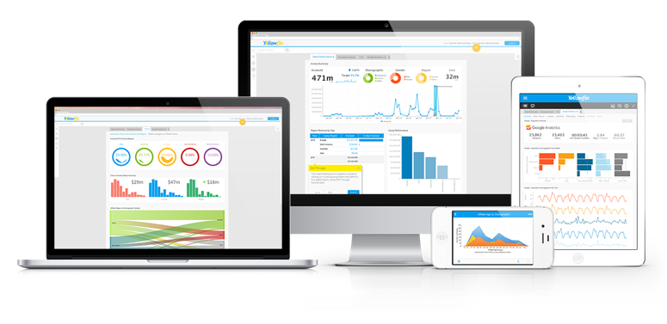
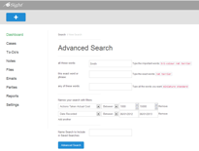
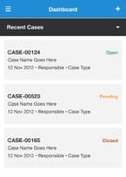
i-Sight’s solution also provides:

- A Web-Based Platform
- Important Alerts
- Case Centralization
- Task Management Capabilities
- Real-Time Dashboards

Book a demo today to find out how i-Sight can help your business.

Connect with us:
1-800-465-6089
info@i-sight.com
i-sight.com
[Replace with your company’s logo]

At {Company Name}, we take all complaints seriously. We strive to respond quickly to complaints regarding acts of discrimination, harassment, and all other forms of misconduct.

This form is to be completed by an employee from Human Resources who has received a complaint from another employee. Use this form to record and track information about the complaint, the complainant, and the accused.

Include as many details as possible and use additional sheets of paper as required.

Please note that, should the complainant ask, the Company may be required to disclose the information recorded in this form on a need-to-know basis.

Thank you.

HR Employee Complaint Form

- Complainant information:
Name ____________________ Employee ID ____________________
Job title ____________________ Phone no. ____________________
Department ____________________ Supervisor ____________________

- Incident type:
- Discrimination | - Harassment
- Assault | - Other ______________________

- Information about the incident(s):
__________________________________________________________________________________________________________________________________________________________________________________________________________________

- Date and time of incident(s): _____________________________________________

- Information about the subject of the complaint:
Name ____________________ Employee ID ____________________
Job title ____________________ Phone no. ____________________
Department ____________________ Supervisor ____________________

- Witnesses to the incident(s):
Name ____________________ Contact information ________________
Name ____________________ Contact information ________________
Name ____________________ Contact information ________________

- Effort made to resolve the incident:
____________________________________________________________________________________________________________________________________________

- Proposed action or desired resolution:
____________________________________________________________________________________________________________________________________________

- Date and time complaint received: ________________________________________

- HR Representative involved: ____________________________________________

- Immediate reactions required? Circle one: Y / N

- If yes, please indicate below:
____________________________________________________________________________________________________________________________________________

- Investigation necessary? Circle one: Y / N

- If yes, name investigator assigned: _______________________________________

* By signing below, I certify that all information provided above is true and correct to the best of my knowledge. I give permission to disclose any information in this complaint on a need-to-know basis and will cooperate fully with investigations.
Complainant signature: ___________________________
Representative signature: ___________________________ | Date: _____________

